SFSA Cast In Steel [Year] – [Item]

Technical Report
[University Name] – [Team Name]

[School Logo]
[Picture of Final Product]

Team Members:
[Insert Names]
Advisor(s) Name:
[Insert Name(s)]
Foundry Partner:
[Insert Foundry partner]
Example:

SFSA Cast In Steel 2030 – Halligan Bar

Technical Report
Rose-Hulman Institute of Technology – Example Team

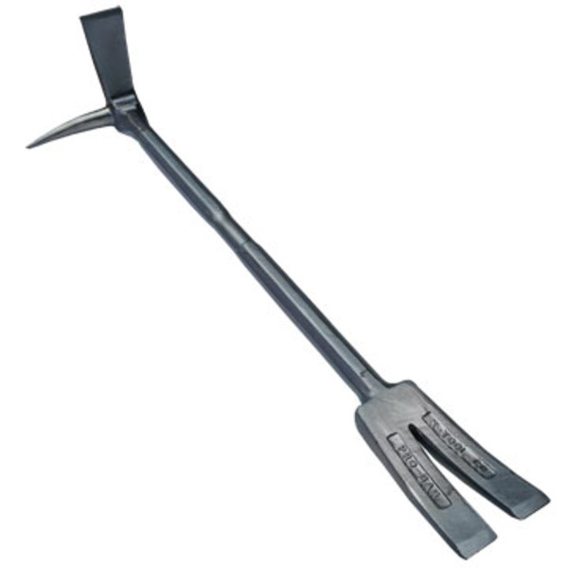

Team Members:
Thing 1, Thing 2, Thing 3, Thing 4
Advisor(s) Name:
The Cat in the Hat
Foundry Partner:
Seuss Forge

